Professors of the MSc
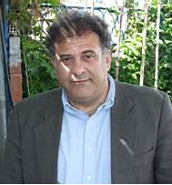
Nikolaos Danalatos: Professor of Agronomy and Crop Ecology. Director of the Laboratory of Agronomy and Applied Plant Physiology of the Department of Agriculture Crop Production and Rural Environment, School of Agricultural Sciences of the University of Thessaly (2006-Today). Dean of the Faculty of Agricultural Sciences of the University of Thessaly (2019-today). Director of postgraduate studies, Faculty of Agricultural Sciences, University of Thessaly (2007-today). He was Vice Rector for the Organization and Operation of Administrative Services of the University of Thessaly (2013-2014) and unanimously elected President of the Department of Agriculture Crop Production and Rural environment of the University of Thessaly for two terms 2014-2016 and 2016-2018. He graduated from the Agricultural University of Athens (1982), received his MSc in Soil Science and Water Management (1983-1986) and PhD in Quantitative Assessment of Land Use Systems (1987-1993) at Wageningen Agricultural University. He is an author of over 190 scientific papers in international journals (64), international book chapters (20), international conferences (106), other conferences and scientific papers. He holds a Greek and international patent for solid biofuel production. He is evaluator of EU research programs, while his work is cited in more than 2100 international papers (h-factor 23). He has actively participated in 20 European Union research projects, coordinating 4 of them. He has taught at pre-and postgraduate level the courses: General and Special Agriculture, Crop Growth Modelling, Biomass Crops for Energy Production, Soil Science, Land Evaluation, Functional Ecology, Land Desertification, etc. He has supervised over 140 undergraduate and 65 postgraduate theses, 6 doctoral dissertations and was a member of the evaluation committee of 40 doctoral theses. His research interests focus on arable crops, cultivation of energy plants for green energy production, cultivation of aromatic medicinal plants, creation of cultivation protocols, efficiency optimization, land use planning, environmental impacts from agriculture, use of cover crops and intercropping systems, and study of soil erosion.
Scopus: https://www.scopus.com/authid/detail.uri?authorId=36942478200

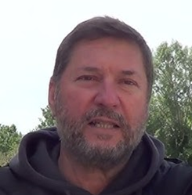
He graduated (1989) from the School of Agriculture, Aristotle University of Thessaloniki, Greece.
He has Ph.D. (2004) in Agricultural Sciences, School of Agriculture, Crop and Animal Production, University of Thessaly, Greece and MSc (2028) in “Environmental Design of Cities and Buildings”, Hellenic Open University, Patra, Greece. He trained during: a) 1997 in the Institute National de la Recherche Agronomique (URIH-INRA) in Sophia Antipolis in France on subjects related to soilless culture methods for ornamental plants grown in greenhouse, computer control of greenhouse climate, computer control of the fertigation in hydroponic cultures, optical and thermal properties of plastic films used as greenhouse cover materials, b) 2004 in Plant Research International The Neterlands (PRI) in Wageningen, on optimization of the management of protected cultivation and use of sensors and remote scanning devises on crop management and c) 2008 in Wageningen Univercity, The Netherlands on Greenhouse Technology. He has professional experience (over 10 years) on soilless crop production, landscape designing, research projects and technical consulting in postgraduate projects. He is an author of over 47 scientific papers in international journals (34), international conferences (13), other conferences and scientific papers (44). His work is cited in more than 350 international papers (h-factor 8). He has actively participated in 20 European Union and National research projects, coordinating 8 of them. He has taught at pre-and postgraduate level the courses: Floriculture, Asexual Plant Propagation, Garden plants and Urban Green, Landscape Architecture, Novel Technics and Strategies for Ornamental Plant Production, Influence of the Abiotic and Biotic Environment on Plant Production, Crop Growth Simulation and Production Assessment, Soilless Crop Production Systems and Technologies, Greenhouse Crop Technologies and Management etc. He has supervised over 39 undergraduate and 10 postgraduate theses, 3 doctoral dissertations and was a member of the evaluation committee of 3 doctoral theses. His research interests include the following: (a) Use of smart systems for the handling of nutrient solutions in hydroponic cultivations. (b) Pre-symptomatic tracing of biotic and abiotic stress in crops. (c) Contribution of urban agriculture in the improvement of urban environment.
Scopus: https://www.scopus.com/authid/detail.uri?authorId=12239204400

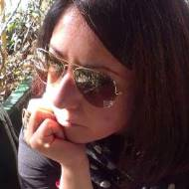
Ourania Pavli is an Associate Professor in Plant Breeding and Director of the Laboratory of Plant Breeding. She earned her MSc in Plant Breeding & Genetic Resources and her PhD in Plant Science, both from the Wageningen University, The Netherlands (PhD Thesis: Beet necrotic yellow vein virus and transgenic approaches towards enhancing rhizomania disease resistance). Also, she has attended various training seminars and workshops in the fields of Biotechnology, Bioinformatics and Systems Biology. Since 2014, she works at the Laboratory of Genetics and Plant Breeding, U.Th., teaching undergraduate and postgraduate courses in the fields of Plant Breeding (Classical and Molecular) and Genetics. She has supervised the research of 3 PhD dissertations, 13 MSc theses and more than 55 BSc theses, while also being a member in a good number of supervising and/or examining committees in undergraduate and postgraduate theses and Phd dissertations. Her research is published in 34 research papers in international scientific journals, 3 book chapters and 87 international and national conferences. She has participated in 7 funded research projects related to the field of Plant Breeding and Biotechnology. Her research is mainly focused on breeding for abiotic and biotic resistance in cultivated crop species as well as on mechanisms regulating stress resistance. Her activity is particularly targeted at the exploitation of molecular and biotechnological approaches, including the 'omic' and genetic engineering technologies, for the purposes of conferring biotic and abiotic stress resistance.
Scopus: https://www.scopus.com/authid/detail.uri?authorId=35337613900
Google Scholar link: https://scholar.google.com/citations?user=cnF7M6MAAAAJ&hl=el
ORCID: https://orcid.org/0000-0002-5276-2184

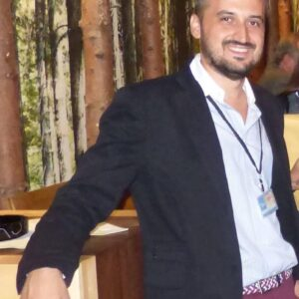
Kyriakos Giannoulis: Assistant Professor of Agronomy with an emphasis on the cultivation of Energy, Aromatic and Medicinal Plants. Member of the Laboratory of Agronomy and Applied Plant Physiology of the Department of Agriculture Crop Production and Rural Environment, School of Agricultural Sciences of the University of Thessaly (2021-Today). He holds three Master's Degrees: a) Integrated Master in Department of Agriculture, Crop Production and Rural Environment, University of Thessaly, b) MSc in “Automation in Irrigation, Agricultural Constructions and Mechanization of Agriculture”, Department of Agriculture, Crop Production and Rural Environment. University of Thessaly, in collaboration with the Department of Automation of TEI of Chalkis, c) Master of Science (M.Sc.), in “Plant Sciences” with specialization in “Crop Sciences”, Wageningen University the Netherlands. PhD in the Faculty of Agricultural Sciences of the Department of Agronomy of Crop Production and Rural Environment, University of Thessaly. He participated in several research projects. The courses he teaches are: Aromatic-Medicinal Plants and Plants for Power Generation, Agronomy, Cereals, Industrial Energy Plants, etc. His research activity has resulted in more than 100 publications in international journals (45), international book chapters (3), international and national conferences (60). His research interests’ focus on cultivation of aromatic-medicinal plants, energy plants for green energy production, arable crops, creation of cultivation protocols, efficiency optimization, land use planning, environmental impacts from agriculture, use of cover crops and intercropping systems.

Scopus https://www.scopus.com/authid/detail.uri?authorId=24338942100
Google Scholar ID https://scholar.google.com/citations?user=CTgCZD4AAAAJ&hl=it
https://orcid.org/0009-0009-6248-9917

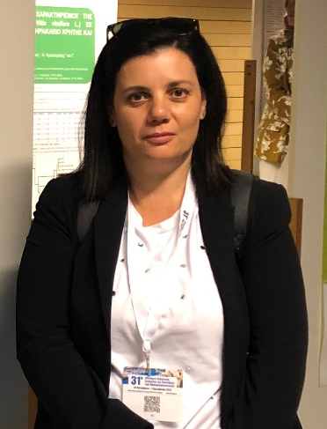
Despoina G. Petoumenou: Assistant Professor of Viticulture and Director of the Laboratory of the Viticulture of the University of Thessaly. She obtained her first degree in Agriculture graduated from the Faculty of Agriculture of the University of Perugia (Perugia, Italy), holds a Diploma in Viticulture and Oenology and her PhD in Viticulture from the Faculty of Agriculture of the University of Perugia (Italy). She is currently Director of the Viticulture Laboratory of the Department of Plant Production and Rural Environment of the University of Thessaly, and she was Visiting Professor of the Department of Wine, Vine and Beverage Sciences of the School of Food Sciences of the University of West Attica. She has published more than forty papers in international journals and proceedings of international and national conferences on topics related to Viticulture and has participated as scientific officer in numerous competitive research projects. Her research interests include, among others, the ecophysiology of the vine, the effects of viticultural techniques and the environmental factors on grape quality characteristics, the promotion of indigenous grapevine cultivars, as well as the impact of climate change on viticulture.
Scopus Author Identifier https://www.scopus.com/authid/detail.uri?authorId=24338942100
Google Scholar ID https://scholar.google.com/citations?user=CTgCZD4AAAAJ&hl=it
https://orcid.org/0009-0009-6248-9917

SCOPUS: https://www.scopus.com/authid/detail.uri?authorId=55508933700
Google Scholar: https://scholar.google.com/citations?user=https://scholar.google.com/citations?user=5CD93KkAAAAJ&hl=en
ORCID: https://orcid.org/0000-0001-9631-4802
Research gate: https://www.researchgate.net/profile/Persefoni-Maletsika


Dr. Persefoni Maletsika is an Assistant Professor in Pomology – Oliviculture at the University of Thessaly since 2021. She has a B.Sc. of the Department of Agriculture Crop Production and Rural Environment of the University of Thessaly (2002). She obtained her M.Sc. from the Interdepartmental Postgraduate Studies Program of the School of Agricultural Sciences of the University of Thessaly in 2004 and her Ph.D. in Agricultural Sciences from the Department of Agriculture Crop Production and Rural Environment of the University of Thessaly in 2015. She teaches at the Department of Agriculture Crop Production and Rural Environment of the University of Thessaly, the undergraduate courses Oliviculture, Pomology I (co-teaching), Specific Pomology (co-teaching) and Organic Agriculture and Innovative Crop Production Systems. She has participated at the Master of Science programme on Sustainable and Viable Crop Production (2021-2024) by teaching the postgraduate courses Pomology and Environment, and Innovations in Pomology. Her scientific interests focus on physiological and biochemical plant responses against abiotic stress factors; nutrition and irrigation management of fruit trees using innovative precision technologies; organic, integrated and conventional fruit tree cultivation; carbon footprint analysis of fruit tree cultivation; sustainable cultural practices effects on fruit quality; postharvest handling and quality of horticultural commodities. She has participated or is participating in six competitive European and national research projects. She has published 25 articles in international peer reviewed journals and proceedings of international conferences, and she has numerous articles in national conference proceedings.

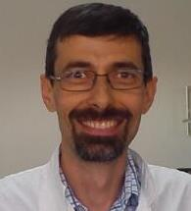
Vasileios Antoniadis: He is Professor in Applied Soil Science and Director of the Laboratory of Soil Science in the Department. He obtained his first degree in Agriculture, in the Direction of Land Reclamation, Soil Science, and Agriculture Engineering (1994) and his PhD in the Department of Soil Science, University of Reading, UK (1999). He is in the Editorial Boerd of Environmental Geochemistry and Health, and Agriculture; hw was also Guest Editor in a Special Issue Toxics. Since 2021 he has been included in the list of the Stanford University top 2% scientists in his area of research. His research interests include the study of the effect of organic novel soil improvers (biochars, frass, sewage sludge, manure, biostimulants) in soil health, and the study of the effect of degraded soils in plant production, especially of soils contaminated with heavy metals.
SCOPUS https://www.scopus.com/authid/detail.uri?authorId=16052031800
Google Scholar https://scholar.google.com/citations?user=GE0Ln_YAAAAJ&hl=el
ORCID https://orcid.org/0000-0002-8820-4934

